**Introduction/Business Problem Section:**

As a person who is planning to migrate to Toronto, Canada, finding a suitable neighborhood for accommodation and settlement is essential. A thorough understanding of various neighborhoods in Toronto is crucial before boarding the flight to Canada. This will help to identify the neighborhoods that has the various features to offer to its residents - such as locations of bars, pubs, restaurants, supermarkets, essential services, neighborhoods that offer a descent nightlife for the youth and younger generations etc.

For people migrating to a new country, it is essential to arrange for affordable neighborhoods which has the required day-today facilities for singles, couples or families during the initial days as there is a lot of hassle involved. If a thorough analysis is not done before putting money for the selection of neighborhoods then there can be financial, mental, physical strain, especially for people who migrate to new countries without a job. Also, staying nearby supermarkets, medical facilities, banks and other essential goods is of paramount importance to avoid unnecessary travel and transport in a foreign land.

This study will give more insights about the city of Toronto and will provide the below information

* Neighborhoods with the count of bars, restaurants, yoga centers etc.
* Neighborhoods with more essential services, medical facilities etc.

**Data Section:**

Data that will be used for this project will be retrieved from Wikipedia

The data collection will involve the following

* Toronto Neighborhood details.
* Neighborhood venues such as bars, restaurants, supermarkets etc.
* Most common venues etc.

**Methodology Section:**

**Data collection:**

1. The data for the Toronto Neighborhoods is freely available on Wikipedia and the data for the project is developed by scraping the Wikipedia website
2. Foursquare API was used to get the various venues around Toronto neighborhoods
3. The Toronto Neighborhood data was divided into 8 clusters and the venues were identified around those 8 clusters

**Analytic Approach**

As a part of this study prescriptive analytics is being used to help someone identify the various venues or events around various neighborhoods in Toronto. K-means clustering was used to develop 5 clusters around the city of Toronto. Each of the clusters were then analyzed to identify the various resources, entertainment centers, supermarkets etc. available in that cluster.

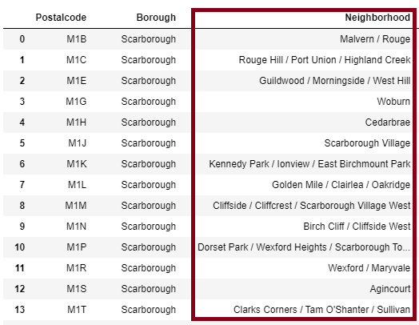

Using folium, we managed to generate the map for the various neighborhoods of Toronto

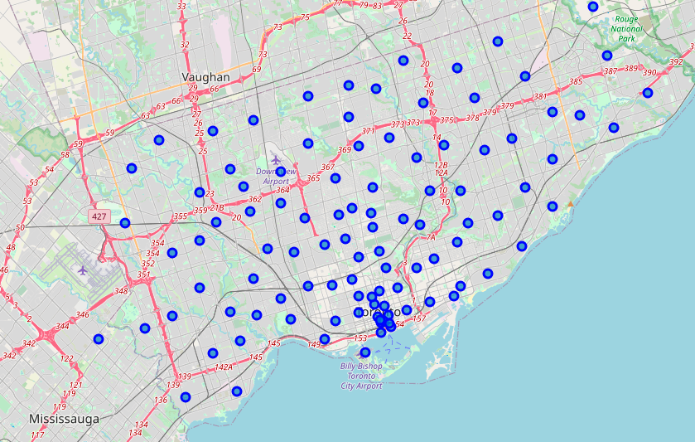

All the available venues were assigned various categories such as Bars, Mexican restaurants, Coffee shops etc. so as to arrive at a count of the total numbers and frequency per neighborhood

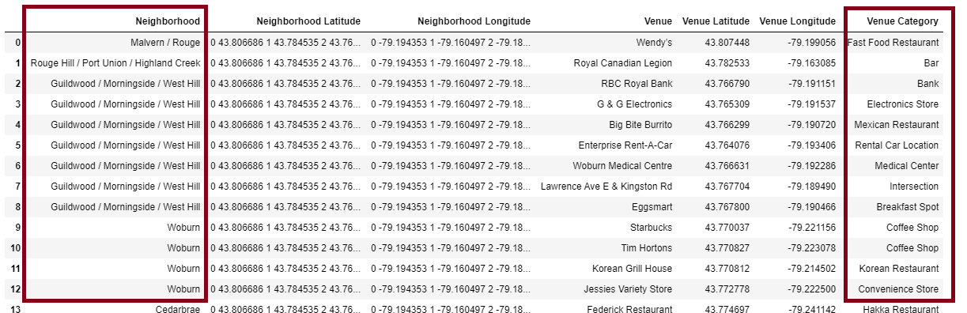

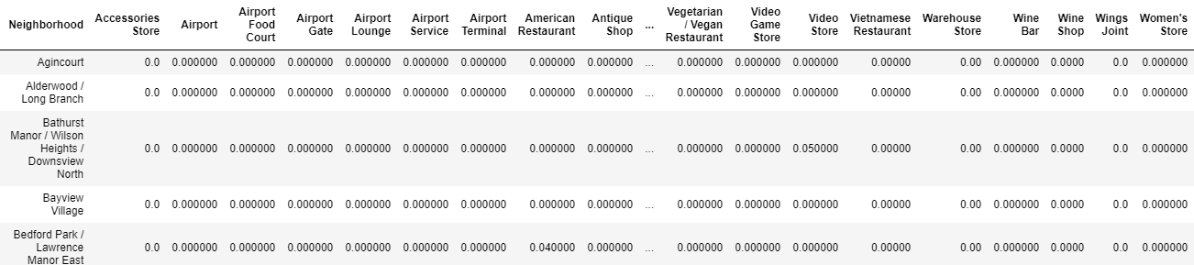

We analyzed the various most visited places for each neighborhood

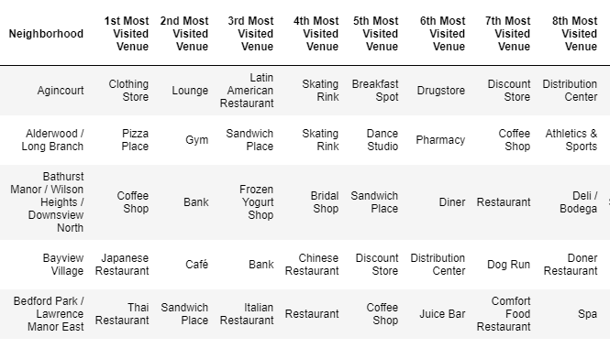

As a part of this study, we created 5 clusters for the neighborhoods and analyzed the data per cluster.

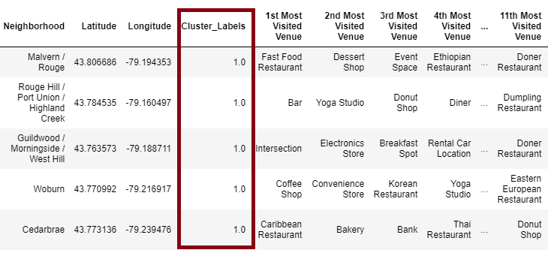

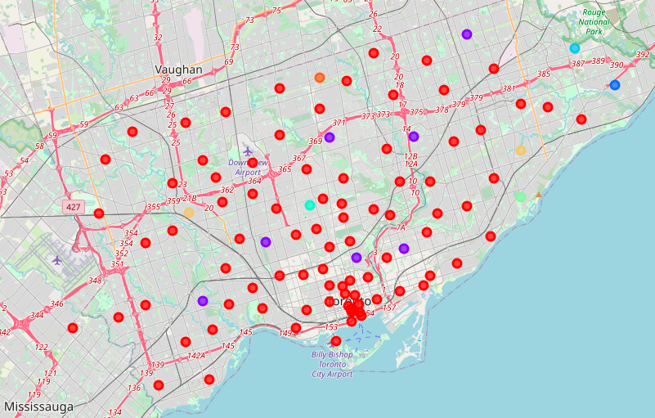

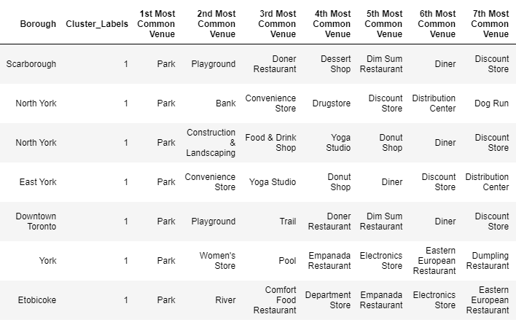

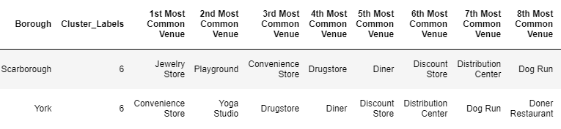

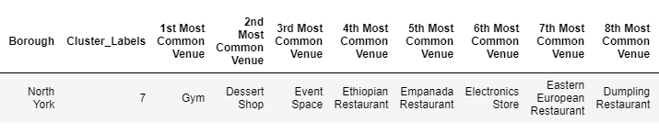

We also analyzed various frequencies for each venue per neighborhood in Toronto city.

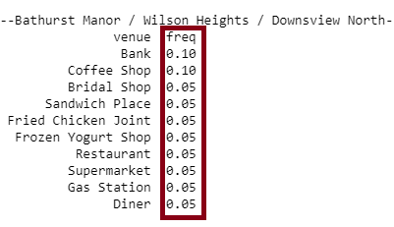

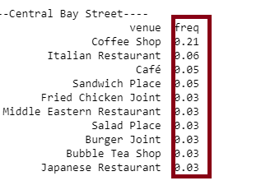

**Results Section:**

As a part of this study, we have analyzed the various venues and locations around the Toronto City. The neighborhoods of Toronto had been analyzed and from the results we can see the most visited places (or venues with higher frequencies) for each neighborhood and the most visited places for each of the 8 clusters that we developed as a part of this study.

For e.g.: The neighborhood around CN tower or Railway Lands has Airport service and Airport lounge more frequently available. However, the rental car locations or boats or ferry are frequency is lesser.

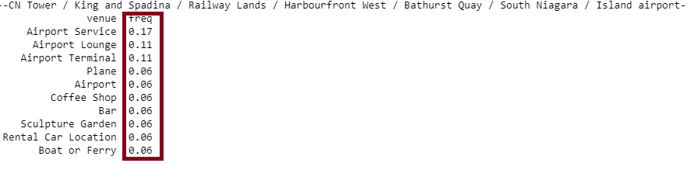

Similarly, the Central Bay street neighborhood has more coffee shops that would attract the office goers and the students. However, the Japanese restaurants are very less in that area.

Therefore, if a Japanese citizen chose to migrate to Canada and settle in the Central Bay street area, then his options for Japanese restaurants will be less.



**Discussion Section:**

Based on the analysis, we can identify the number of venues based on the categories for each neighborhood. This demonstrates the venues and the resources that each neighborhood has to offer for the residents. Based on these details, people (the intended audience for this study), who have decided to migrate to Toronto, Canada can go through the analysis data and then make an informed decision while selecting a neighborhood for settling down.

For example, for Alderwood/Long branch, the Pizza Place is the most visited venue. Similarly, for Bayview village, the Japanese restaurant is the most visited place. For Bathurst Manor, the Coffee shop is the most visited place followed by Banks. Hence, there is a higher probability of having banking services available.

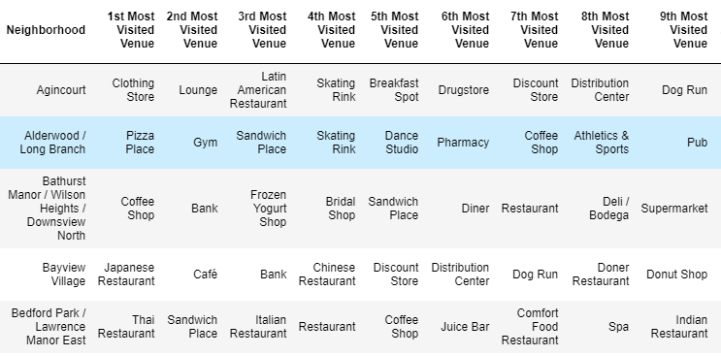

**Conclusion Section:**

In this study, various aspects of the Toronto Neighborhoods were verified and analyzed using the various Data science concepts and tools. An existing data set from Wikipedia on Toronto Neighborhood was used in collaboration with the data collected from Foursquare API. Data was also scraped from website to generate the required data for analysis. Exploratory data analysis and the clustering concepts were utilized to achieve the goal of this study. As a part of the study, we managed to arrive at satisfactory answers to the questions we posed before the study.